Temple
Israel

Temple Israel Monthly Bulletin
November 2016

“We are our stories. We tell them to stay alive or keep alive those who only live now in the telling. That’s how it seems to me, being alive for a little while, the teller and the told.” Niall Williams wrote this and yet it felt like I could have said it after the High Holiday services. Not only the stories we hear in the Torah and haftarah portions, in poetry, but also those we heard in the congregational discussion on Yom Kippur and will hear each time a sukkah is raised.
Message from the President

Temple Events

- Nov 3rd - 6th – Play Diary of Anne Frank
- Nov 5th – CHUM Dinner
- Nov 6th & 7th – Silver Lecture Series
- Nov 10th – Publication Reading
- Nov 11th – New Member Shabbat Meal
- Nov 17th – Give to the Max Day
- Dec. 30th – Hanukkah dinner

Our holidays couldn’t have been accomplished without Mike Grossman’s coordination… whether working with R. David, Andrea Gelb, Lainie Ribnick, Michelle Wallerstein, Kathy Levine or Renee Coda, or their working with Erin Aldridge; Tina Alcala-Seles, Ben Yokel, and Bart Polacsek; DuSTY, and babysitters … Mike is at the center making sure all is accomplished so we can enjoy, be challenged, and experience our High Holidays. Todah rabbah! After all was said and done our community was able to celebrate together at a meal sponsored by the family of Erwin Goldfine and presented by Jeff Wallace and crew. And who set up, moved, and cleaned in preparation … Marko … and then took down, moved and cleaned, all with the help of a few able men and women of our community. I can’t help but say it, it does take a village. And I haven’t even mentioned all the participants in services …

Our holiday celebrations didn’t end there … Sukkot began the following day with the board unsuccessfully completing the raising of the sukkah. As Sue Ginsberg mentioned, there’s a joke in our experience that lends itself to, “How many Jews does it take to put up a sukkah?’ Far more than you’d ever guess … I actually think there’s a Purim skit involved! But I digress. It was beautifully decorated by the Religious School and Hebrew School children

and there were wonderful celebrations in it … and, in Overman Hall afterwards. Thank you to Andrea Buck for making this all possible.

During the intermediate days of Sukkot, we had an Elder’s Lunch featuring the president of the League of Women Voters who gave a presentation and answered questions about the voting process. It was another great program coordinated by Jim Perlman. Jim’s time with the board is coming to an end in December and I would like to thank him for all his work as the chair of the Programming Committee these past years.

Jim will also be recognized by the Depot Foundation in October with the Community Enrichment Award. We have certainly been the beneficiary of his experience.

We are our stories.

See you in shul!

Chris

“Temple Israel is a welcoming and vibrant
center of Jewish life for our region,
l’dor vador… from generation to generation.”

From the Rabbi’s Study

Rabbi’s bulletin article for November 2016/ Tishri-Cheshvan 5777

The Hebrew month of Cheshvan, which comes between Tishri (filled with all of the fall holidays – Rosh Hashanah, Yom Kippur, Sukkot and Shemini Atzeret/Simchat Torah) and Kislev (culminating with Chanukah) – has no special holidays of its own. In Jewish tradition, this month is sometimes called “Marcheshvan” (“bitter Cheshvan”) to reflect this lack of special holidays.

Actually, when I was a little kid I was taught that “Marcheshvan” meant “Mr. Cheshvan” – that, given its lack of holidays we should go out of our way to treat the month with respect and dignity because otherwise it will “feel bad.” (Similarly, I was taught that we cover the challah on a Shabbat table because the challah will feel bad if it knows that we are giving a much longer blessing (Kiddush) for the wine than the challah gets for itself [hamotzi])

I sort of like those more playful explanations even if, to cite Stephen Colbert, they may have more “truthiness” than “truth” in them…

In any event, November this year almost exactly corresponds with the month of Cheshvan.
However, as Rabbi Mordecai Kaplan (the founder of the Reconstructionist movement) taught, we American Jews “live in two civilizations.” And it is certainly true that the American holiday of Thanksgiving both draws from Jewish sources and inspires us as Jews.

Regarding the latter idea, I remember when I was in rabbinical school at RRC one of my teachers, Rabbi Nancy Fuchs-Kreimer, used to invite students who were away from their families to her home for Thanksgiving dinner – and we’d start the meal with a big challah shaped like a Turkey.

And when I was in my early twenties spending a year working between college and law school, my (Jewish) supervisor at the law firm where I worked as an administrative assistant routinely referred to Thanksgiving as “yuntif.” (Yiddish for “holiday” – as if the fourth Thursday in November were also a traditional Jewish holiday).

It is told that in creating the American Thanksgiving holiday, the Pilgrims drew on the tradition of the Jewish holiday of Sukkot, one of whose themes is that of thanksgiving for the
fall harvest. (One of the traditional names for Sukkot is “Chag Ha’asif”/ “The festival of the ingathering [of crops].)

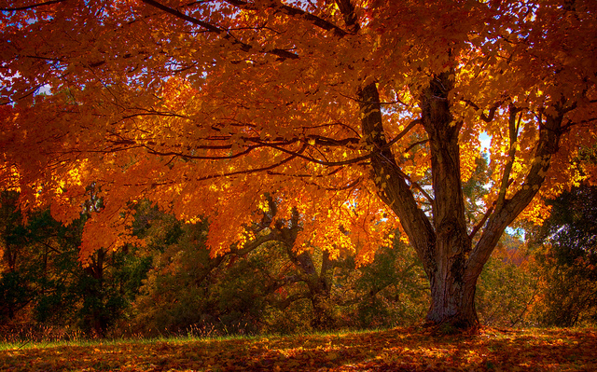
In fact, in Judaism, every day is Thanksgiving Day, as the Amidah (in both its weekday and Shabbat versions) always includes “Birkat Hoda’ah” (The blessing of thanksgiving.)

Every year, several congregations in central Duluth gather together for an interfaith Thanksgiving service on the last Tuesday evening before Thanksgiving. (Congregations in West Duluth and in Lester-Lakeside have their own joint Thanksgiving services.) This year, the Central Duluth Interfaith Thanksgiving Service is taking place at the Unitarian Universalist Congregation of Duluth, 835 West College Street, on Tuesday, November 22nd at 7:00 p.m. I hope that many of you can attend so that Temple Israel can be well-represented at this community gathering. There is also an opportunity to sing in an interfaith community chorus being organized for the occasion. See more details elsewhere in this bulletin about that.

The upcoming Interfaith Thanksgiving service is only one of several local interfaith events in which our congregation has been or will be represented. To cite a few examples, on September 23rd we enjoyed back to back visits of Temple members visiting the Islamic Center of the Twin Ports for their Friday afternoon service and members of the ICTP visiting our congregation for our Friday evening Shabbat service and dinner. During Sukkot week, Temple members joined with members of Glen Avon Presbyterian Church in working with Western Lake Superior Habitat for Humanity on a building project. And on Sunday, November 6th, Temple Israel’s annual Silver Interfaith Memorial Lecture series will bring biblical scholar Joel Hoffman to our congregation in a presentation of interest to a wider interfaith audience. See more details about that event elsewhere in the bulletin.

Returning to the theme of Thanksgiving, let me take this opportunity to express my thanks to everyone who helped make our fall holiday services so beautiful and meaningful.
Todah Rabbah/ Thanks very much to:

The High Holiday committee under the able leadership of Mike Grossman; all of our ushers; all of our Torah and Haftarah readers; our Ba’alei Tekiah (shofar players) Maureen O’Brien and Gerry Wallace; our wonderful Temple Choir and instrumentalists under the direction of the amazing Erin Aldridge; our DuSTy adviser Lainie Ribnick and our youth group members for leading the family services on Rosh Hashanah and Yom Kippur; Michelle Wallerstein for

coordinating babysitting; Beverly Goldfine and family for sponsoring the Yom Kippur break-the-fast; and Andrea Gelb for organizing the Yom Kippur afternoon discussion (and to all the panelists who participated in it). Thank you also to the many people, both Temple volunteers and paid helpers, who took part in setting up, cooking and cleaning up of all of our holiday meals. And thank you to our Temple staff---Renee Coda, Marko Jukic, Andrea Buck, Mona Cheslak, Lainie Ribnick, Jeanne Kogl and Peter Pierce -- for the commitment and professionalism they bring to their work at Temple Israel, not just during the fall holiday season but throughout the year. Thank you also to everyone who helped put up the Temple sukkah (and to all the kids who decorated it). And thank you to our “Sukkah Hop” hosts --- Chris and Dan King, Mike Grossman and Holly Church, and Debbie Friedman and Peter Wodrich. (And a general thank you to Chris for her able presidential leadership and compassionate presence during the fall holidays and throughout the year.)
And a personal thank you from me to Jeff Wallace for helping me (read: “letting me help him”) to put up my personal sukkah. I apologize that I just didn’t have the kuyekh* this year to host a sukkah hop at my own sukkah – but I hope, God willing, to do so next year. (And while I’m praising Jeff Wallace --- a big public thank you to Jeff for catering the break-the-fast, and for lovingly baking the challot for our onegs and Kiddush lunches throughout the year.)
If I have forgotten to mention anyone (and I’m sure I have), please accept my apologies and I’ll plan to add to my thank you’ s in my December bulletin article if I learn of such omissions.

L’shalom,
Rabbi David Steinberg
rabbidavid@jewishduluth.org

(*”Kuyekh” – in case you didn’t know, is Yiddish for “strength” [Essentially, the Ashkenazi version of Hebrew “Ko’ach”] )

Saturday, March 20th
Lorem ipsum dolor sit amet, consectetuer adipiscing elit, sed diam nonummy nibh euismod tincidunt ut laoreet dolore magna aliquam erat volutpat. Lorem ipsum dolor sit amet, consectetuer adipiscing elit, sed diam nonummy nibh euismod tincidunt ut laoreet dolore magna aliquam erat volutpat.

Sunday, March 27th
Lepsum dolor sit amet, consectetuer adipiscing elit, sed diam nonummy nibh euismod tincidunt ut laoreet dolore magna aliquam erat volutpat. Epsum factorial non deposit quid pro quo hic escorol. Olypian quarrels et gorilla congolium sic ad nauseum. Souvlaki ignitus carborundum e pluribus unum. Lorem ipsum dolor sit amet, consectetuer adipiscing elit, sed diam nonummy nibh euismod tincidunt ut laoreet dolore magna aliquam erat volutpat.

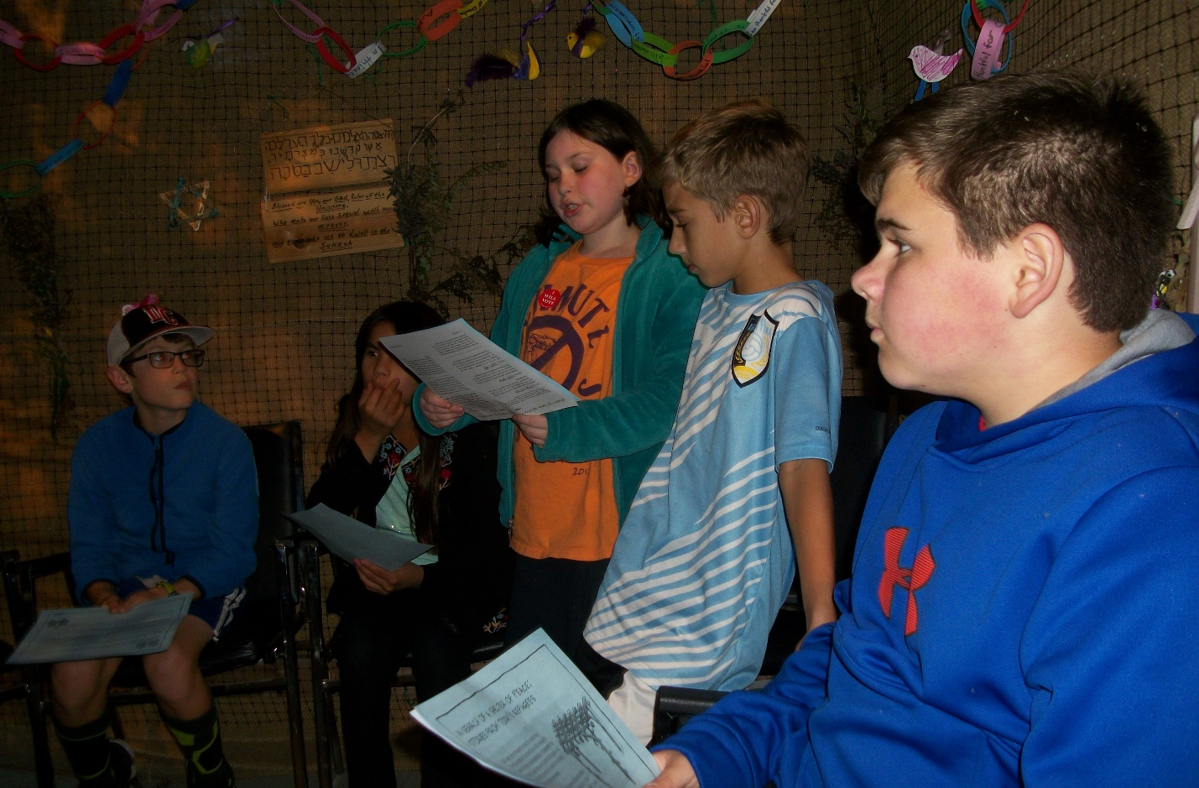
One of the things I enjoy when teaching our children about Judaism and their Jewish heritage is being able to tie lessons from Torah and on rituals, traditions and ethics, in meaningful ways to their lives today.
This Sukkot, for example, students in my Gimmel Hebrew class got a glimpse of the refugee situation in the world. Using an idea from HIAS, a Jewish refugee organization, we discussed how spending time in the sukkah is a way to connect to the fragility of life and the fact that many people today – the homeless and refugees – don’t have four solid walls and a strong roof over their heads at night to keep them protected from the elements and secure from intruders.
The children, thanks to materials researched and prepared by HIAS, learned about four of the world’s estimated 65 million refugees and displaced people:
- Rawan, a 4-year-old boy, fled with his family from their home in Qamishli, Syria when he was 1. He doesn’t remember home. He now lives in a former Saddam Hussein prison where the children are encouraged to paint murals on the walls to give them hope. There is no school. Rawan is described as a mischievous boy who loves to be flipped upside down and takes giant bites out of your food when you aren’t looking.
- Kamal left Afghanistan as a child when his father was targeted by the Taliban because of his service in the Afghan army. They passed through many countries – Turkey, Khazikstan, Pakistan, Iran – until they landed in Russia. But as Muslims, they weren’t welcomed. Kamal was beaten twice. After 17 years, difficult security screenings and a long vetting process, he and his brother have resettled in the U.S.
- An unnamed woman from war-torn Darfur, Sudan sought refuge in a camp in Chad. In her profile, she recalls that the war began on a Tuesday, two days after market day. Many in her family and from her village died from the attacks or later from hunger. Food is scarce in the camp and she reminisces on the abundance of food -- tomatoes, millet, mango and livestock -- before the war.
- Carlos was forced to flee Colombia when he witnessed the massacre of his fellow farm workers by a paramilitary self-defense group in 2009. He and a friend hid behind the cattle
Jake, Zippy, Zach, Aryanna and Gabe invited Rawan and Kamal to the synagogue Sukkah during our service to welcome the ushpizin (guests).

- they were tending. He now owns a Chinese food business in Ecuador where his landlord overcharges him for the space and people assume he’s a drug dealer because he’s Colombian.

That night all students helped collect small shampoos, soaps, lotions, deodorants and items such as toothbrushes and disposable razors for the homeless in Duluth. While making decorations for the sukkah the week before, they were encouraged not only to take joy when dwelling in this temporary shelter, but to reflect on what it would be like if they actually had to live in the sukkah especially if it were cold or raining. The toiletries are being donated to the CHUM center where they will be given to people who need them.
Todah Raba
I learned this year that it really does take a village to erect a sukkah. A sincere thank you to all board members and Dan Wallerstein, Gunnar Johnson and Lily Johnson who helped in this process, even though some glitches with the walls and a lack of tools. Thanks to Marko Jukic for cleaning up some very messy classrooms after our decorating session and setting up extra tables and chairs for our sukkah event. Thanks to Chris King and Jeanne Kogl for serving the food and kitchen cleanup that night.

Thank you to Maureen O’Brien for demonstrating to our young students the different shofar blasts and showing each of them how to sound the shofar.
News from the Hebrew and Religious Schools
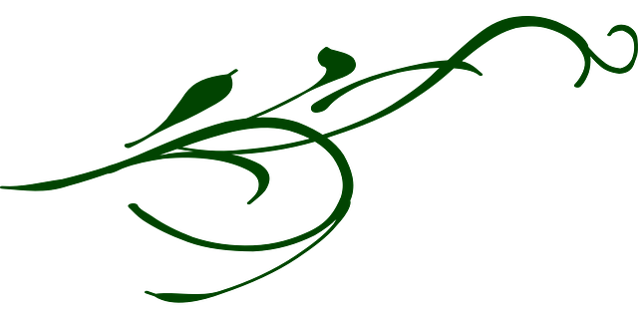

HIGH HOLIDAY TODAH RABAH - THANK YOU!

Providing meaningful High Holy Day services takes the efforts of many, many dedicated individuals. Once again this year I have the great pleasure of offering my thanks to our incredible and dedicated synagogue staff, Renee, Marko, Jeannie and the Kitchen crew, to those behind the scenes who “prepared the plate” for our services, including Linda Eason (honors selection), Tom Griggs (honors selection), Wallerstein (babysitting arranging), Chris King (contacting congregants about honors), and Jeff Wallace (chef extraordinaire), as well as to those whose work is clearly visible: Rabbi David, he of soaring melodies and challenging sermons who sets forth and guides our spiritual journey, gabbis Janet Rosen, Maureen O’Brien (both gabbi and shofar blower), Sue Ginsburg, Linda Eason, Neil Glazman, and Casey Goldberg, shofar blower Gerry Wallace, and Kathy Levine (Tashlich).

Also appreciation is due to head usher Josh Widdis and his crew of ushers, Lainie Ribnik and our DuSTY youth (children’s services), organizer and moderator Andrea Gelb and panelists Tina Alcala-Sales, Bart Polacsek, Cindy Seiler and Ben Yokel (Yom Kippur congregational discussion), and poets Linda Glaser and Jim Perlman. A special shout-out this year to those congregants who helped set up tables and chairs after Shabbat services before each holiday, and to DuSTY members Hannah Widdes and Ben Wallerstein who assisted beforehand with setting tables for the post Yom kippur meal.

I think I can confidently speak for the entire congregation in appreciating the beauty that musical director Erin Aldridge and the Synagogue Choir bring to our services, which so elevates my holiday experience.

Kudos

HIGH HOLIDAY TODAH RABAH - THANK YOU!

Providing meaningful High Holy Day services takes the efforts of many, many dedicated individuals. Once again this year I have the great pleasure of offering my thanks to our incredible and dedicated synagogue staff, Renee, Marko, Jeannie and the Kitchen crew, to those behind the scenes who “prepared the plate” for our services, including Linda Eason (honors selection), Tom Griggs (honors selection), Wallerstein (babysitting arranging), Chris King (contacting congregants about honors), and Jeff Wallace (chef extraordinaire), as well as to those whose work is clearly visible: Rabbi David, he of soaring melodies and challenging sermons who sets forth and guides our spiritual journey, gabbis Janet Rosen, Maureen O’Brien (both gabbi and shofar blower), Sue Ginsburg, Linda Eason, Neil Glazman, and Casey Goldberg, shofar blower Gerry Wallace, and Kathy Levine (Tashlich).

Also appreciation is due to head usher Josh Widdis and his crew of ushers, Lainie Ribnik and our DuSTY youth (children’s services), organizer and moderator Andrea Gelb and panelists Tina Alcala-Sales, Bart Polacsek, Cindy Seiler and Ben Yokel (Yom Kippur congregational discussion), and poets Linda Glaser and Jim Perlman. A special shout-out this year to those congregants who helped set up tables and chairs after Shabbat services before each holiday, and to DuSTY members Hannah Widdes and Ben Wallerstein who assisted beforehand with setting tables for the post Yom kippur meal.

I think I can confidently speak for the entire congregation in appreciating the beauty that musical director Erin Aldridge and the Synagogue Choir bring to our services, which so elevates my holiday experience.

This year I again want to offer thanks to those of you who stepped in for an honor at short notice, or agreed to step in at the last minute, whether you ultimately needed to or not. You know who you are. And, although it’ s not a ritual matter and I’ve had nothing to do with any aspect of it (beyond partaking!), I would like to add here a personal note gratitude for the Erwin Goldfine Break-the-Fast meal. It’s a delicious way to start the new year, and a wonderful community builder.

This year I again want to offer thanks to those of you who stepped in for an honor at short notice, or agreed to step in at the last minute, whether you ultimately needed to or not. You know who you are. And, although it’ s not a ritual matter and I’ve had nothing to do with any aspect of it (beyond partaking!), I would like to add here a personal note gratitude for the Erwin Goldfine Break-the-Fast meal. It’s a delicious way to start the new year, and a wonderful community builder.

Finally, it is a marvelous testament to the dedication and responsibility of our Congregational community how smoothly High Holiday services go overall. A great and heartfelt thank you to all of you who accepted honors and participated in the services: who read English
selections, who tended the Ark, who carried, held or dressed Torah, who performed aliyot, and who read Torah or Haftarah. You honor our Community, as we
honor you.

If everything appeared to go smoothly, if High Holy Day Services met our spiritual needs, the congregation is indebted to each of the above. All deserve the many compliments and appreciations I’ve received on this year’s services, plus my own very deep gratitude (with sincere apologies if I’ve missed anybody).

— Mike Grossman —

TODAH RABBAH/ Thanks very much to Shimon Shaked, owner of the “I Love Duluth” shop in Canal Park, for his donation of a large supply of Caribou Coffee which we will all be able to enjoy at upcoming onegs and Kiddush lunches.

Congratulations to Jim Perlman on being selected to receive the “Community Enrichment Award” of the Depot Foundation. Jim will be honored at the 2016 Arts and Culture Awards Ceremony on October 26th.

Thank you to Temple members Tom Griggs, Mike Baddin and Steve Davis who participated in the Western Lake Superior Habitat for Humanity work day on the second day of Sukkot. And thank you to everyone who made monetary donations in connection with this work.

Some Noteworthy Dates
Consecration of new students will take place during Shabbat morning services on Saturday, Oct. 29. Please join us to celebrate these four children who are beginning their formal Jewish studies.
There is no school on Wednesday, Nov. 23 or Saturday, Nov. 26, due to the Duluth Public Schools’ break.

Upcoming Events
Publication Reading
Please join us for a publication reading by Minneapolis author Fred Amram, from his memoir We're in America Now: A Survivor's Stories (Holy Cow! Press, 2016) at the Kathryn A. Martin Library Rotunda, UMD campus, on Thursday evening, November 10th. The reading begins at 7 pm. Amram will share excerpts from his memoir about his life as a Jewish child in Nazi Germany, and as an émigré in the US. His story keeps the Holocaust–not only the event in history, but also the potential for its repetition–before everyone’s eyes. The event is free and open to the public; books available for purchase. For additional information, please contact Holy Cow! Press, 218-724-1653.

New Member Shabbat Meal
Come join us for dinner to welcome new Temple members on Friday, November 11th following service. The menu for dinner that evening will be Spiced Fried Fish with Lemon Pistachio Couscous OR Apple Cranberry Stuffed Squash with Walnuts
Accompaniments: Garlic Honey Green Beans, Deviled Eggs Magic Pan Salad, Breads and of course a variety of desserts. Please make reservations by Wednesday, November 9th, through the Temple office and, when calling, specify Fish or Squash as entrée choice.
Price: $15.00 - $10.00 seniors and $7.00 children

Translating the Siddur: An Intermediate Level Hebrew Class for Adults
In this class we are working on parsing, word by word, phrase by phrase, key prayers of the Shabbat evening and morning services. Our “textbooks” will be the siddurim themselves that we use here at Temple Israel --- The Reform siddur Mishkan T’filah for the Shabbat evening service and the Reconstructionist siddur Kol Haneshamah: Shabbat Vehagim for the Shabbat morning service.

The class is appropriate for anyone who already has basic knowledge of liturgical Hebrew grammar and vocabulary and already has some facility with reading the Hebrew of the siddur without transliteration into English characters.

The purpose of the class is to be able to pray in Hebrew during services with comprehension of the literal meaning of the texts.

For those students who have been taking intermediate Hebrew with Rabbi David during the last couple of years, much of this will be review of topics we’ve previously studied, but applied to new texts.
Central Duluth Interfaith Thanksgiving Service
This year's Central Duluth Interfaith Thanksgiving Service is scheduled to take place at the Unitarian Universalist Congregation of Duluth, 835 W. College Street, on Tuesday, November 22nd at 7:00 p.m.

As part of the service, there will be a community-wide choir open to members of all of the various participating congregations including our own. It will be conducted by the UUCD’s music director Karen Bauman. We will be singing Stand Upon the Rock by Rollo Dilworth, a piece described by the composer as a "modern-day anthem for peace, equality and social justice". If you would like to sing in the interfaith choir, you are welcome to attend a rehearsal on Sunday Nov. 20th from 4:30 - 5:30 at the UUCD. In addition, there will be a final rehearsal at 6:15 p.m. on November 22nd, the night of the service.

Please contact UUCD music director Karen Bauman directly, at kklgb4820@msn.com or by phone at the UUCD at 218-724-0308 if you plan to participate in the interfaith Thanksgiving service choir and/or if you have any questions.

The Diary of Anne Frank
On November 3-6 the College of St. Scholastica will be performing the play The Diary of Anne Frank. Tickets can be purchased on-line at the Spotlight page on the College of St. Scholastica website: http://www.css.edu/about/spotlight-arts-and-lectures/arts/st-scholastica-theatre.html
There are still 4 tickets free for the asking. First come, first serve. Let Renée know if you are interested.

Annual Chum Dinner
Temple Israel will be hosting a table for the CHUM Annual Dinner, Saturday, November 5th at Holy Family Catholic Church - 2430 W. 3rd St. Duluth. Doors open @ 6 PM - Silent Auction/Wine and Beer Served. Dinner is at 7 PM and the program at 7:45 PM. Suggested contribution is $50. For more information, contact www.chumduluth.org

Remember those in care facilities
Shirley Goldberg - St. Anne's
Dorothy Slonim - Benedictine Health Center

Condolences
Paula Carlson
Theresa Cheng

Birthdays
Nov.1- Alan Apter
Erin Aldridge
4 -Travis Goldish
Connie Jacoby
5 - Stephanie Love
6 - Lillian Woodrich
8 - Elizabeth Kaplan
9 - Jay Aldridge
Barbara Kenner
Isabell Tusin
10 - Ben Yokel
11 - Arianna Loons
14 - Alexis Pogorelskin
17 - Gary Latz
Sharon Kaner
Alice Loons
18 - Sam Buck
19 - Dori Streit
20 - Allyz Kramer-Polacsek
21 - Burton Cohen
Linda Eason
22 - Sam Perlman
23 - Lillian Alpert
24 - Shirley Goldberg
27 - Aaron Grossman
29 - Joshua Kanoff

Anniversaries
Nov. 11 - Mike Olson and Kathy Levine
15 - Jeff Wallace and Susan Ginsburg
18 - Rob and Kristin Shamblott

The Temple Bulletin is currently in need of a sponsor.
The sponsor will have the opportunity to place a monthly ad in this section. If you would like to sponsor the bulletin, please contact the Temple Office at 724-8857
or via email admin@jewishduluth.org.

The class meets on selected Tuesdays from 5:15 to 6:15 p.m.

Remaining classes are on 11/15, 11/22, 11/29, 12/6 and 12/13.

If you are interested in participating in the class, you can feel free simply to show up. However, if you have any questions about it, please contact Rabbi David Steinberg at 218-724-8857 or by e-mail at rabbidavid@jewishduluth.org

MARK YOUR CALENDAR: "Give to the Max Day" is Thursday, November 17th. Did you know that we received $1,900 in Give to the Max Day gifts in 2015?! Thanks so much to all those who donated last year; the outpouring of support was truly inspiring.

We’re hoping that even more people will make a gift during this year’s event, since our most recent financial report showed that we were $3,600 short of our $8,000 budgeted goal for General Fund donations (as of September 30). So any amount you contribute for Give to the Max Day will play an important role in helping balance the 2016 budget.

Please consider making a gift to Temple Israel on November 17 in any one of the following ways:
- You can give electronically on our very own website: just go to www.jewishduluth.org and click on the Donate button on the top right-hand side.
- You can pay by check, either dropping it off at the office or putting it in the mail. Either way, we will include all checks received, dated, or postmarked on 11/17 in our Give to the Max total.
- You can donate through GiveMN.org. Just go to the GiveMN.org website and type in Temple Israel of Duluth in the search box; be sure to include “of Duluth” to make sure your gift is directed to our Temple Israel. (GiveMN will deduct a 6.9% fee from your gift to cover their own costs and credit card fees.) Gifts made through GiveMN.org will have the chance to earn matching funds and incentive prizes for Temple Israel; you can find more details on their website.

This is a great opportunity to support Temple Israel. Thanks so much for considering a gift. Feel free to call (218.590.6933) or email (roadrunner1836@gmail.com) Janet Rosen if you have any questions.

Janet Rosen, volunteer coordinator of Temple Israel’s Give to the Max Day
Minyan Call List Update
The Temple office is in the process of updating our Minyan Call List. This is a list of those community members who are willing to be called upon at the last minute to assure that a minyan (quorum of ten Jews over the age of Bar/Bat Mitzvah) is present for services. Whether or not you have already signed up in the past, please call or e-mail the Temple office to let us know if you would like to be included in the updated list. Please include the best phone number for you to be reached if we need to call you. Thanks very much.

Temple Israel Board Members
President:
Christine King (president@jewishduluth.org)
1st Vice President: Josh Widdes
2nd Vice President: Rob Shamblott
Secretary: Theresa Neo
Muriel Abram
Sue Ginsburg
Debbie Freedman
Tina Alcala-Salès
Jim Perlman
Janet Rosen
Bart Polacsek
Ben Yokel
Mark Weitz
Deb Carroll

Temple office hours:
Tuesdays – 7:30 am to noon
Wednesdays – 1:00 pm to 6:30 pm
Thursdays – 7:30 am to noon
Fridays – 8:30 am to 1:30 pm
Send in your articles  by the 15th for next month’s bulletin | Temple Israel  1602 E Second Street  Duluth, MN 55812  www.jewishduluth.org | Contact the Temple’s administrative assistant, Renée Coda  at admin@jewishduluth.org

